If you encounter problems copying your assignment from the Cloudera Quickstart VM to your host computer in order to submit an assignment you may need to use the following instructions. The instructions are the same for both Windows and Mac computers.

*Requirements*: You must have the Cloudera Quickstart VM imported into VirtualBox. The Cloudera Quickstart VM should be off during the setup.

1. Open **VirtualBox**, select the **cloudera-quickstart-vm** and click the **Settings** button.

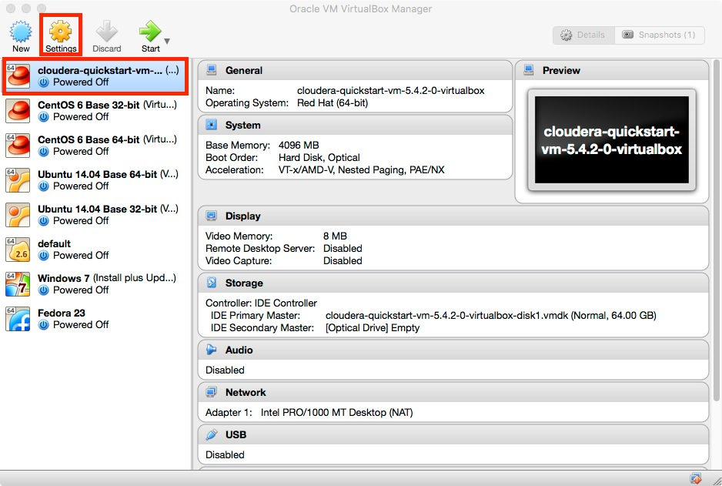

2. Select the **Network** button from the Settings window.

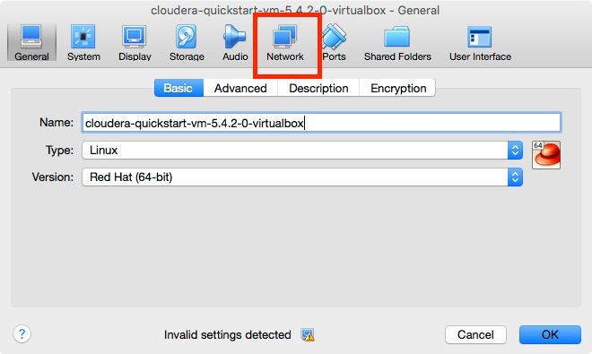

3. Click the **triangle** next to the word **Advanced** to show the advanced options.

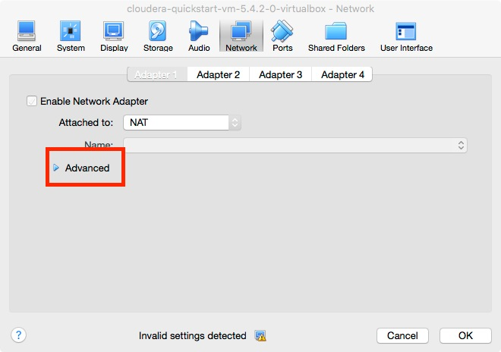

4. Click the **Port Forwarding** button.

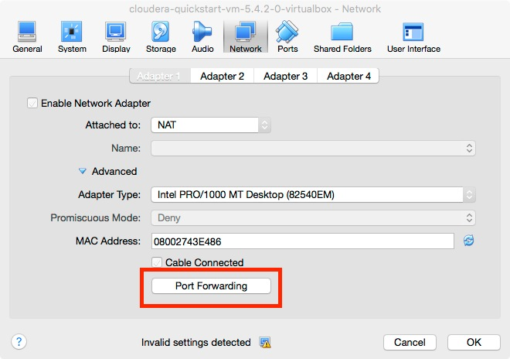

5. Click the **+** button.

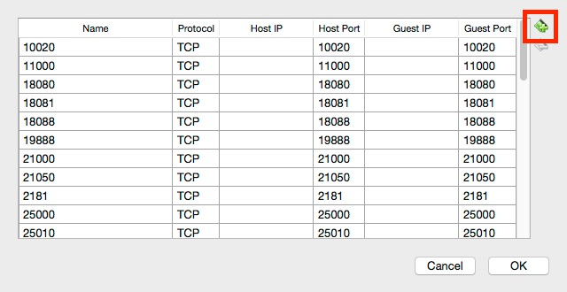

6. In the text boxes, enter:

Name: 22

Protocol: TCP

Host IP: <leave blank>

Host Port: 2222

Guest IP: <leave blank>

Guest Port: 22

Then click the **OK** button and click the **OK** button again on the Setting window to save the settings.

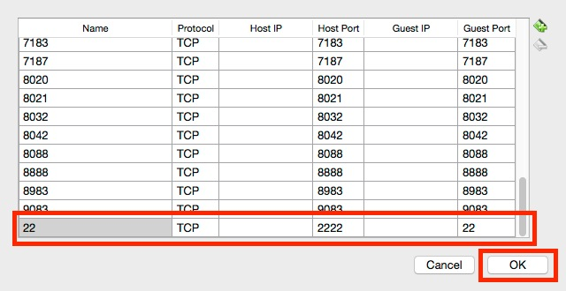

7. Download and install Cyberduck from [https://cyberduck.io/?l=en](https://eventing.coursera.org/api/redirectStrict/tHnzQp2xPse_5-YPapwf52D_RdRejXQyiAiy-JcNpXyXpJlZlu9SJlQ4fTk21rs06n_txKvxsdCCiMcuQRkfsA.j2u1MFvu36vK_HC_rR2zww.X9j_K0zi2__2w3vLvE8K3-byWkYhF-Yx2mQllpTU2L8l0BngVQwYYIM2TJP3wS7PCzMNiAw0jAlGwAb7cJn1JzeSmOo728O1XrJB7NKCgTVnZpEatAYmD6abqhSb4ef-bp58e3bkbqfWhlU9XeBxGjqINV_E84j7wHLQ5ruM5JD8LNTu6P0BDyfPaHCuuPmfci7xO1K9J9TURnC1OTZaZQF5t_bcph5xqPc6h1u-OHzKbX2Po4CjUSfszcL_9RE0Tsf_C94mjijYQ5f9isBNaw) . Power on the Cloudera Quickstart VM and wait for it to boot up completely before proceeding.

8. Open Cyberduck and click the **Open Connection** Button.

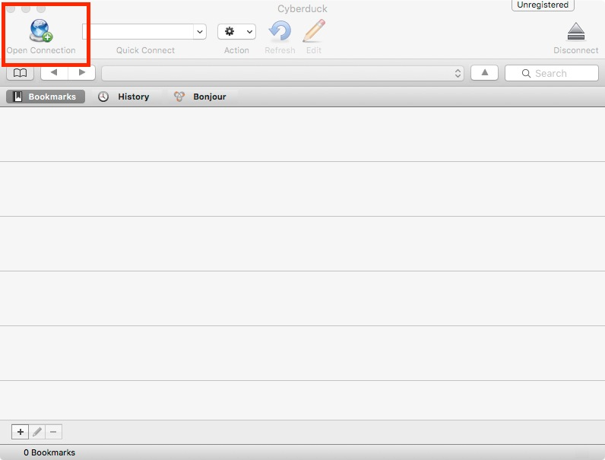

9. Enter the following connection settings:

Connection Type: SFTP (SSH File Transfer Protocol)

Server: localhost

Port: 2222

Username: cloudera

Password: cloudera

Then click the **Connect** button.

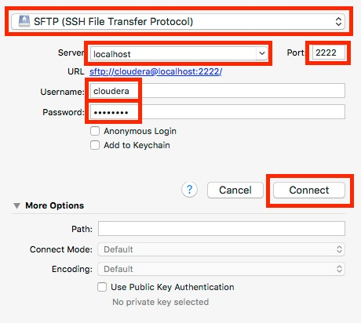

10. Once you have connected you should see all of the files in the cloudera home directory. To download a file to your host computer, find the file then right click on the filename and choose the **Download** option.

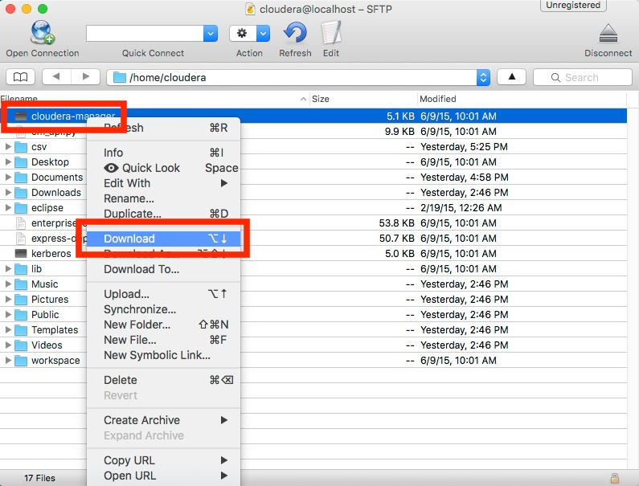

[Additional Resource: Hadoop Related Reading Material](https://www.coursera.org/learn/intro-to-big-data/supplement/RfBuT/additional-resource-hadoop-related-reading-material)

[Previous Item](https://www.coursera.org/learn/intro-to-big-data/supplement/RfBuT/additional-resource-hadoop-related-reading-material)

[Count Words with MapReduce](https://www.coursera.org/learn/intro-to-big-data/programming/T69HR/count-words-with-mapreduce)

[Next Item](https://www.coursera.org/learn/intro-to-big-data/programming/T69HR/count-words-with-mapreduce)